MAT259
Visualize an SQL Query in Processing
Yeu-Shuan Tang
INTRODUCTION

How many numbers of checkouts about photographic books each month during 2006-2012?
I’m interested in the tendency of checkouts about photographic books during the pass seven years. Also, according to checkouts, I’m wondering is there any correlation between photography and season?

BACKGROUND & SKETCHES

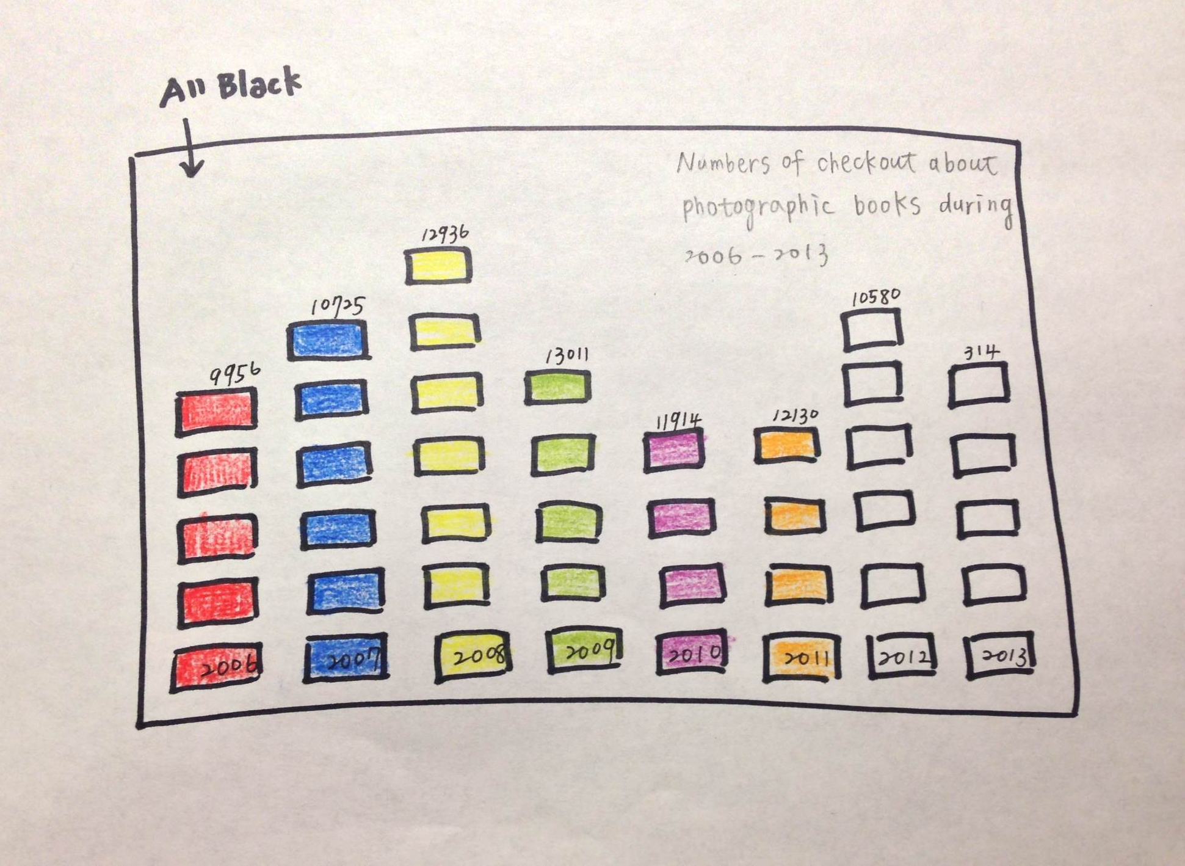

QUERY

SELECT
year(o),month(o),
SUM(CASE WHEN kind="acbk" THEN 1 ELSE 0 END)as book,
SUM(CASE WHEN kind="jcbk" THEN 1 ELSE 0 END)as jcbook
FROM
title, activity, kind
WHERE
title like "%photogra%"
AND activity.bib=title.bib
AND activity.item=kind.item
AND year(o)>2005
AND year(o)<2013
GROUP BY
month(o), year(o)
OEDER BY
year(o),month(o);

QUERY EXPLANATION

I searched items about photographic books from title, activity, and kind. Then, I counted adult books and juvenile books separately from 2006 to 2012. The result is group by each month and year in ascending order.

RESULT AND ANALYSIS

The result of processing is depicted as below. The tendency of checkouts shows the maximum in 2009, and gradually decreasing since then. In addition, it’s interesting during 2009 to 2012 that the tendency of checkouts is quite similar over each month with the minimum point in September.

