Robert Miller
March 4, 2014
MAT259

Concept:
The Seattle Public Library has many items that have a large number of physical copies. I will collect all of the items in the SPL that have more than 50 physical copies, and look at the distribution of various item types. Within these items, I will also collect information about the subject matter and the relative popularity of these items. My goal is to try to explore whether the items that appear in bulk in the SPL actually warrant their quantity given their popularity. The visualization will essentially be a collection of several 3D tree maps.

Query:

SELECT itemtype, bibNumber FROM inraw UNION ALL SELECT copies, bib FROM copies WHERE copies > 50 UNION ALL SELECT subject.subject, bib FROM spl2.subject INNER JOIN inraw ON bib=bibNumber;

Sketch:

The visualization will consist of several platforms, each holding the a group of items with a certain number of physical copies (i.e., one platform for items with 50-59 copies, one for 60-69 copies, etc.) The height of the bars will correspond to the popularity of the item type category, and the color represents an item type. 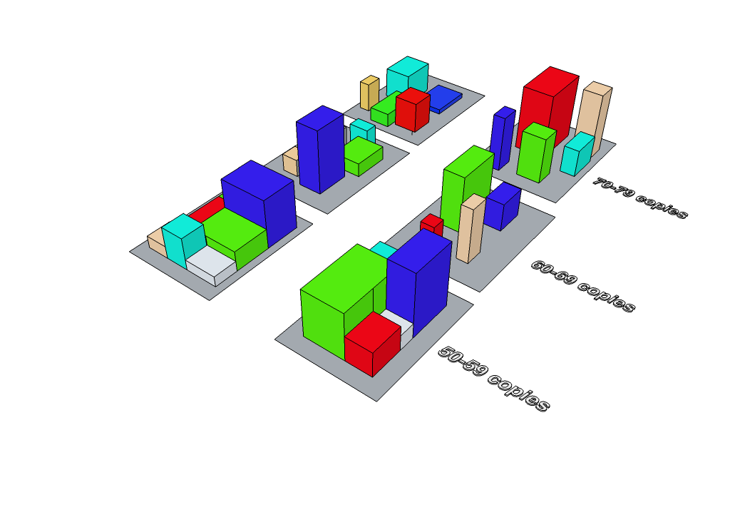
Interaction:
The user will be able to toggle labels on or off and the user will be able to view just a single item type or multiple item types.

